**Neurodivergent Education for Students, Teaching & Learning (NESTL) Toolkit – Case Study 1**

📖 **Case Study 1: Syllabus Accessibility Statement | Dr Laura Seymour**

*Senior Lecturer in English, Swansea University*

The following statement is provided by Dr Seymour, also shared in the earlier section. Please feel free to adapt and develop your own syllabus accessibility statement.

*‘Ensuring accessibility for disabled and neurodivergent students, whether or not they have a diagnosis, is an essential part of my job. I have taken the following steps to make my classes more accessible [insert them here: e.g. I provide lecture recordings and welcome contributions from students according to their preferred communication style]. I encourage students to get in touch with me in confidence by [insert a variety of communication methods here, including one anonymous method] to let me know about any additional adjustments you need. I understand that your access needs may change throughout our time together, and encourage you to let me know about these changes.’*

**For more detailed guidance, examples, activities, and case studies, see the full** [**NESTL toolkit**](https://www.education.ox.ac.uk/project/neurodivergent-education-for-students-teaching-learning-nestl/)**.**

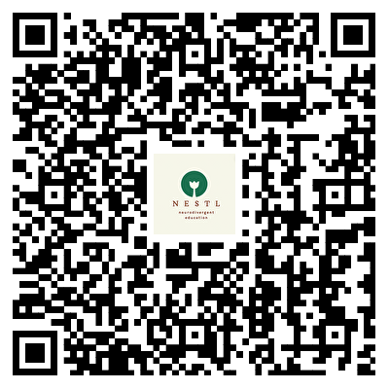

**NESTL Toolkit**