**Neurodivergent Education for Students, Teaching & Learning (NESTL) Toolkit - Key Resource 4**

**✅ Individual Checklist on Assessment and Feedback**

*This checklist is based on the contents in the section on Individual Initiatives. It is not intended to be prescriptive, and you don’t need to implement all of the suggestions, or all at once. Use it to reflect on your approaches to assessments and feedback, consider incremental changes that can make them more accessible.*

**Rethinking Assumptions and Practices**

Reflect on your assumptions about intelligence and how they influence your assessment expectations.

Consider whether your ideas of a ‘high-performing student’ may exclude neurodivergent ways of learning and demonstrating knowledge.

Focus on facilitating learning rather than judging innate ability.

**Inclusive Assessment Design**

Where possible, offer flexibility in assessment formats that allow students to demonstrate their strengths.

Allow a grace period for late submissions, especially for non-summative assignments.

Accept and encourage unpolished drafts in formative assessments to support writing development.

Review your assessment criteria for potential bias and consider how some descriptors may disadvantage neurodivergent students.

**Constructive and Accessible Feedback**

Be clear with students about what your feedback will look like and how it will be delivered.

Ask students what feedback format is most helpful for them (e.g. written summary, bullet points, audio, or 1:1 conversation).

Where possible, provide different feedback options and let students choose what works best for them.

Focus feedback on specific skills and strategies for improvement, not on inherent ability.

Use clear, strengths-based language and avoid ambiguous or overly critical phrasing.

Signpost relevant support services that can help students build academic confidence and skills.

**For more detailed guidance, examples, activities, and case studies, see the full** [**NESTL toolkit**](https://www.education.ox.ac.uk/project/neurodivergent-education-for-students-teaching-learning-nestl/)**.**

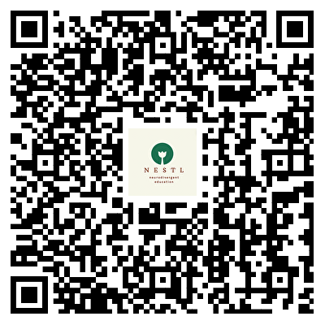                       

**NESTL Toolkit**