**Neurodivergent Education for Students, Teaching & Learning (NESTL) Toolkit - Key Resource 7**

**Glossary**

**Access intimacy** | Access intimacy, coined by disability justice activist [Mia Mingus](https://leavingevidence.wordpress.com/2011/05/05/access-intimacy-the-missing-link/), is the feeling of intimacy and connection that occurs when we communicate our access needs to someone (or several people), and the other person or people listen to what we have to say and meet our needs. Understand that not everyone will want to share their access needs at first, or at all, in the process of teaching and learning.

**Accommodations / adjustments** | Changes we make for other people, so that they can participate in an activity.

**Burnout** | Being physically and emotionally drained, often as a result of overwork, not enough rest, not enough time to be one’s authentic self, and too much masking or social time around other people.

[**Disability Advisory Service**](https://www.ox.ac.uk/students/welfare/disability) **(DAS)** | DAS is a University of Oxford service that ‘provides information and advice on disability issues and facilitates support’ for disabled students at Oxford. Students must register with DAS in order to receive a Student Support Plan (SSP), which then grants them accommodations such as extensions, extra time during exams, and other accessibility resources such as equipment or software. DAS has a staff of advisors who are assigned to each college. You can refer to [this page](https://www.ox.ac.uk/students/welfare/disability/needs) about the evidence needed to register with DAS.

**Disability drift** | Treating a disabled person as if they have another disability which they do not in fact have. For example, talking slowly and loudly to a person in a wheelchair as if that person is d/Deaf when in fact they are hearing, or treating a person who stammers as if they also have an intellectual disability when in fact they don’t. In situations where ‘disability drift’ occurs, one type of disability drifts and blurs into another. This concept was articulated by Jay Dolmage.

**Fidget toys** | Items that people use to fidget: to help focus, regulate emotions, and to play. They may be manufactured for this purpose (e.g. fidget spinners) or ad-hoc (e.g. a pebble someone keeps in their pocket to fiddle with).

**Stimming/Tics** | Words and movements that punctuate a person’s speech and behaviour. Often repeated or repetitive. Stims and tics are often described as ‘involuntary’, but as Remi Yergeau has shown we should be wary of neatly mapping the voluntary/involuntary dichotomy onto the neurotypical/neurodivergent binary. Neurotypical people make all kinds of involuntary movements and utterances every day, and many neurodivergent people can play around with, decide to unleash, and (albeit often with pain and suffering) deliberately repress their stims and tics.

[**Student Support Plan**](https://academic.admin.ox.ac.uk/disability/student-support-plan#collapse1661101) **(SSP)** | The SSP sets out the ‘reasonable adjustments recommended for a student’ in order to ensure their learning is accessible and is shared with relevant staff members (i.e. librarians, course conveners, educators). A student may also share their SSP with you directly. Regardless of whether a student has an SSP, they may have access needs and require accommodations that are not formally recorded, but are equally as valid.

**For more detailed guidance, examples, activities, and case studies, see the full** [**NESTL toolkit**](https://www.education.ox.ac.uk/project/neurodivergent-education-for-students-teaching-learning-nestl/)**.**

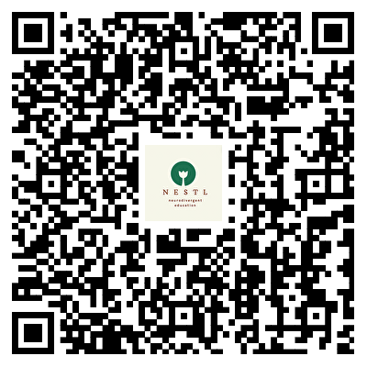                       

**NESTL Toolkit**